SQL Assignments
Please use the previous assignment dataset “redbus”.
Insert more values so that you can see the results.
- Display all passengers whose status is Confirm.
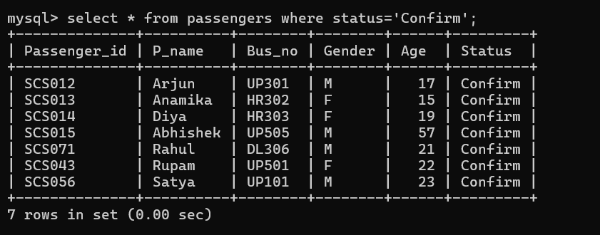
- Display all buses whose fare is more than 1200.
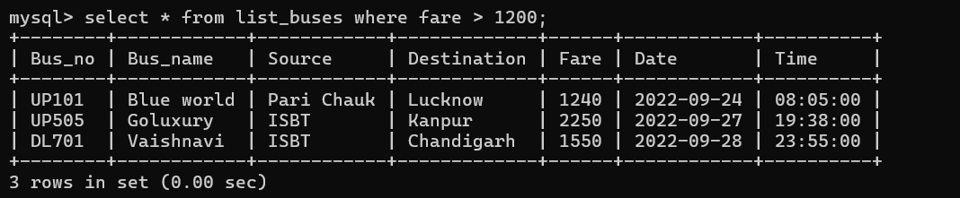
- Display all passengers whose age is less than 18.
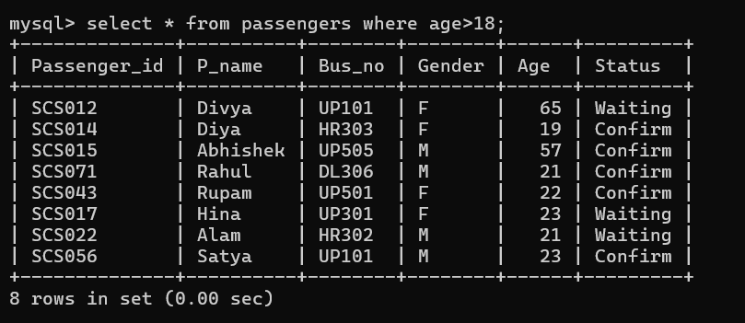
- Display all buses going to Chandigarh.
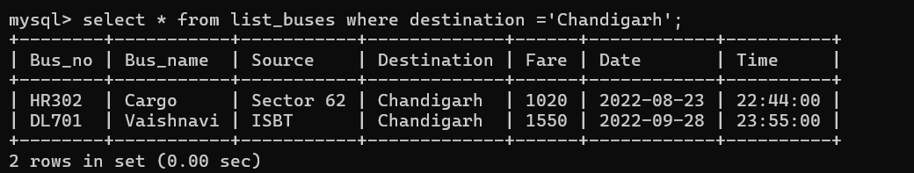
- Display all buses running from ISBT.
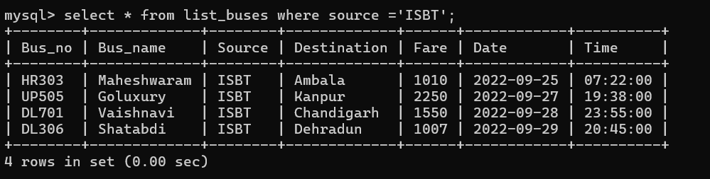
- Display passengers whose names start with ‘A’.
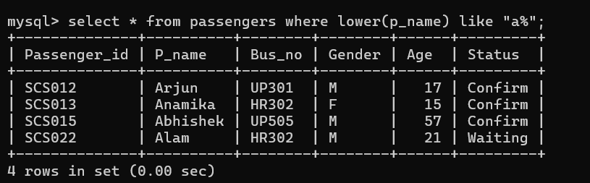
- Display passengers whose names end with ‘a’.
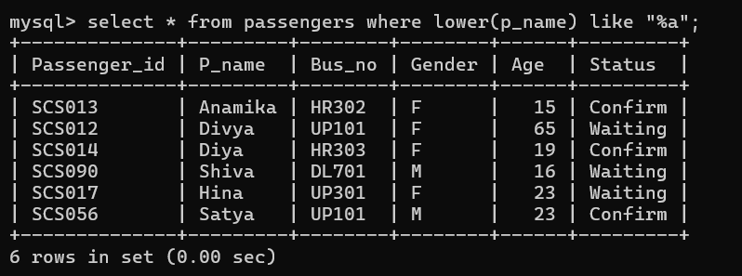
- Display all bus numbers starting with ‘UP’.
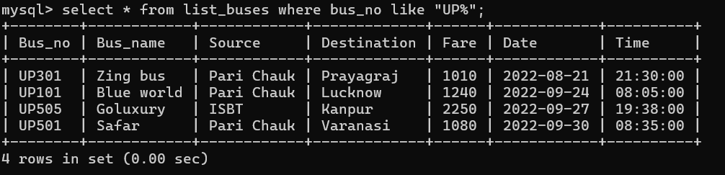
- Display all bus names containing the word ‘bus’.
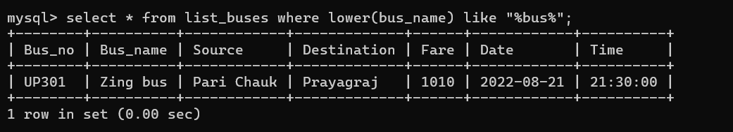
- Display destinations containing the letter ‘a’.
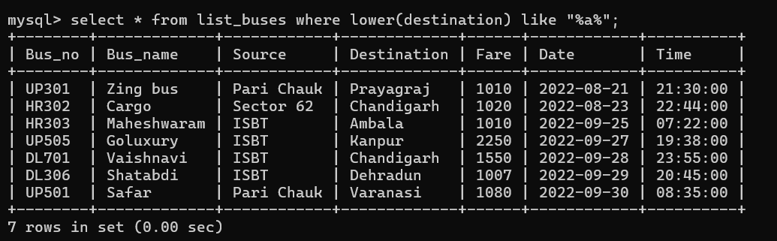
- Display passengers travelling in buses UP301, UP101 and UP501.
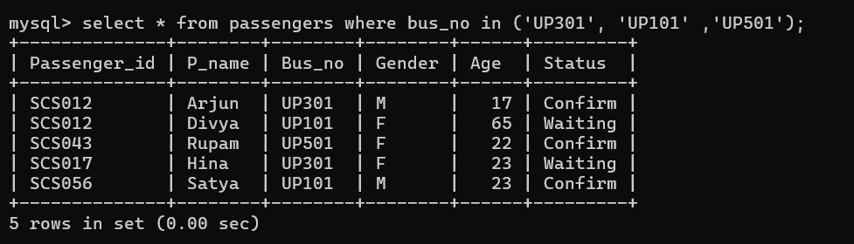
- Display all buses whose fare is between 1000 and 1500.
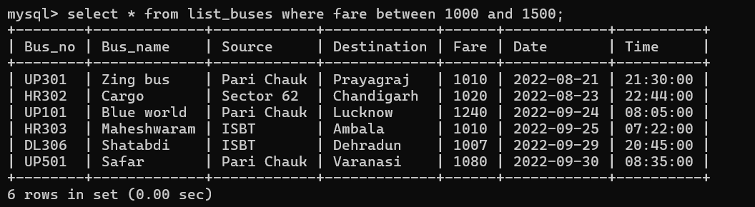
- Display all passengers whose age is between 18 and 30.
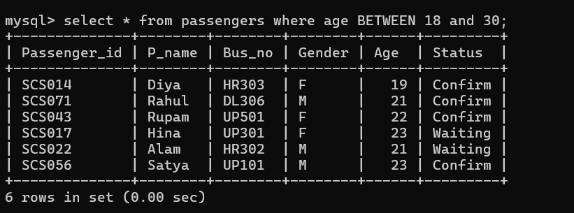
- Display buses whose source is either ISBT or Pari Chauk.
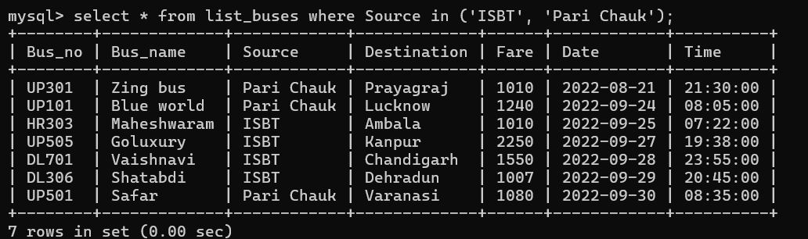
- Find the total number of buses.
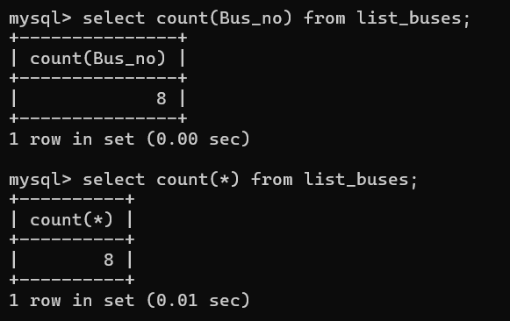

- Find the total fare of all buses going to Chandigarh.
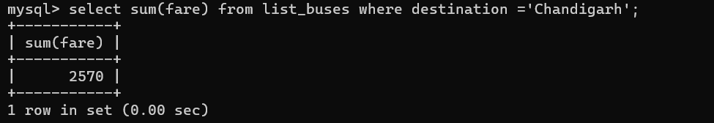
- Find the average fare of buses starting from Pari Chauk.
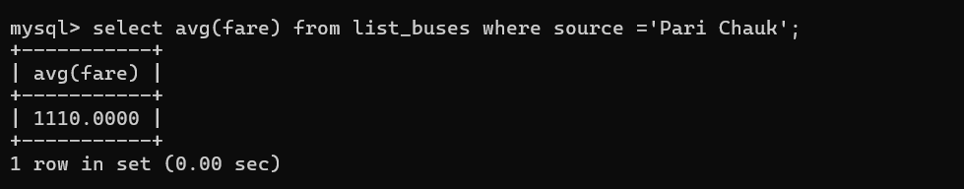
- Find the number of confirmed passengers.
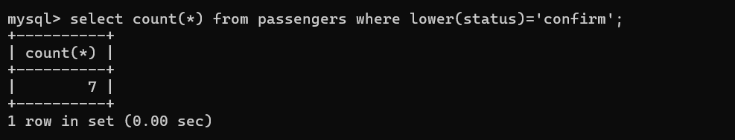
- Find the total number of available seats.
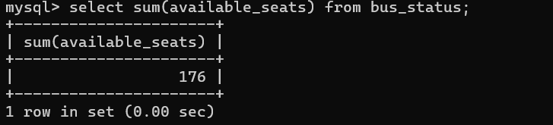
- Find the number of buses from each source.
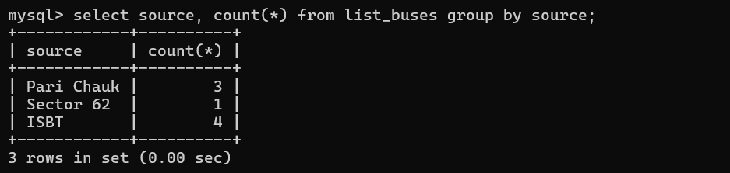
- Find the number of passengers travelling in each bus.
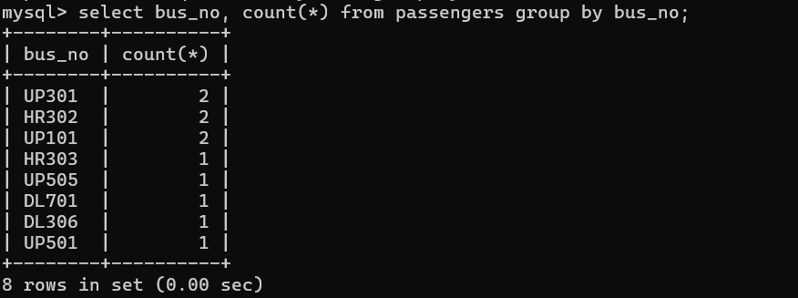
- Find the average fare for each destination.
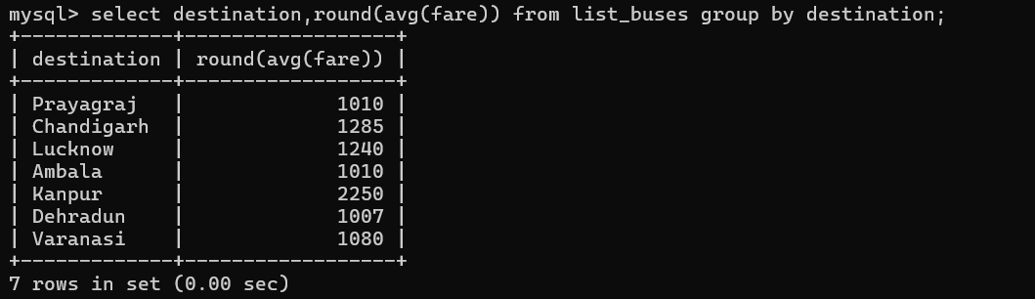
- Display only those sources having more than one bus.
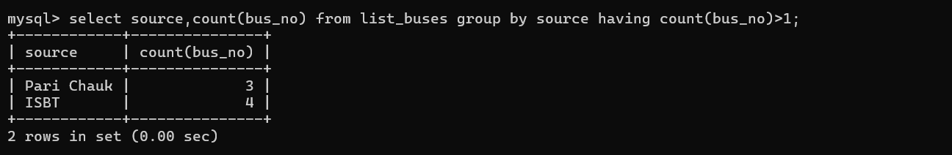
- Display only those buses having more than one passenger.
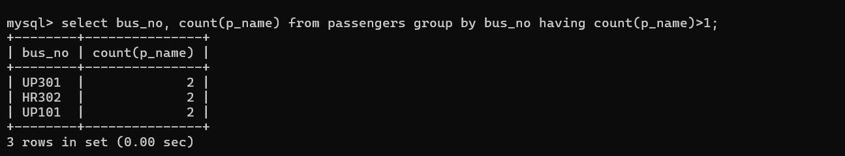
- Display only those destinations whose average fare is greater than 1200.
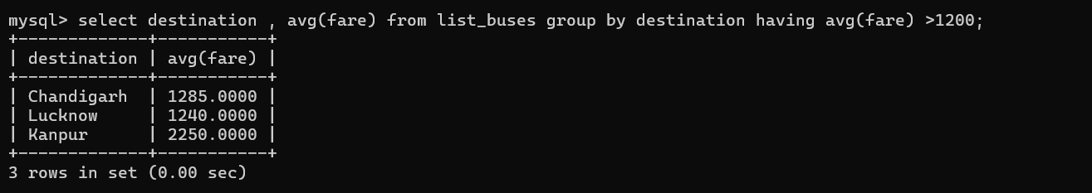
- Display all buses in descending order of fare.
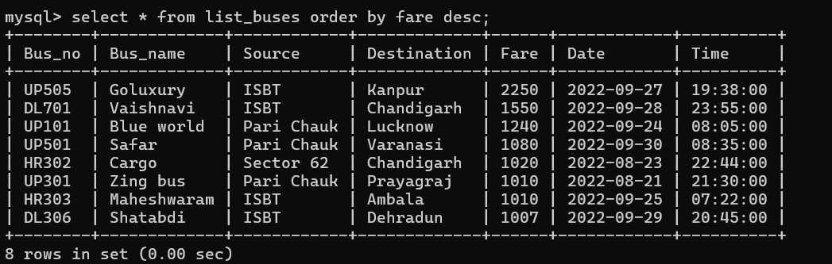
- Display all passengers in ascending order of age.
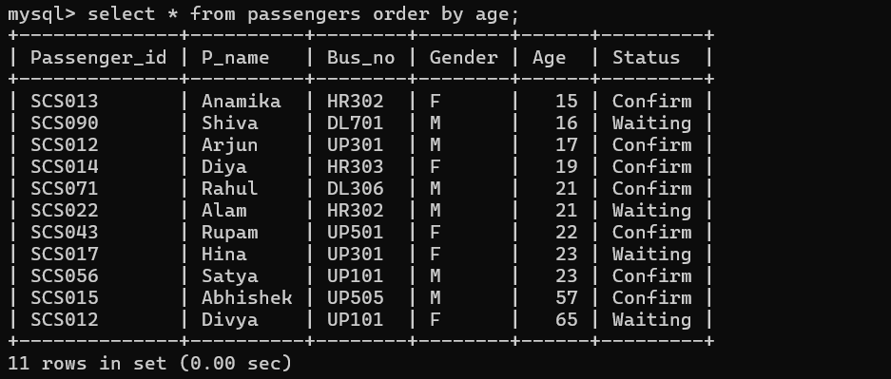
- Display all buses ordered by date and time.
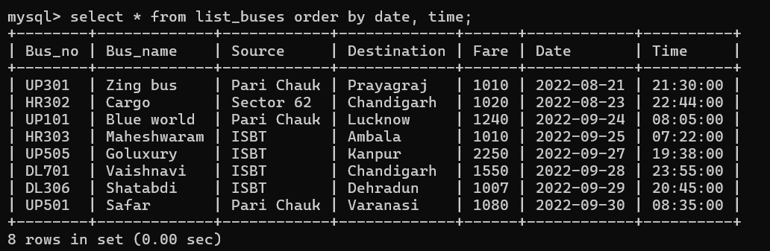
- Find the youngest passenger.
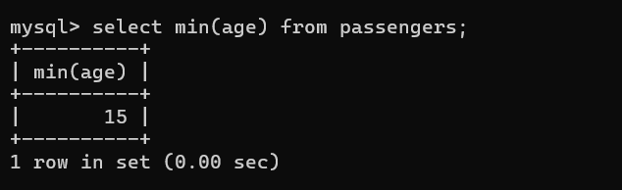
- Find the 4th youngest passenger (handle duplicate ages).
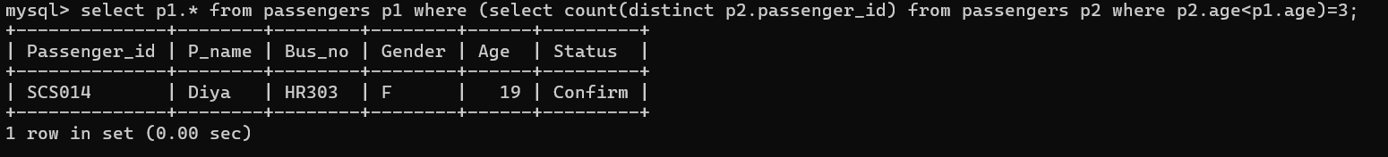
- Find the highest fare bus.
